Data communication and Computer Networks
Open Ended Lab (OEL)
Mapped CLO | BT Level | Graduate Attribute (GA) | SDG
CLO1 | P1 | GA2 | 4
CLO2 | A2 | GA6 | 4
CLO3 | C4 | GA4 | 4
GROUP MEMBERS:
Hira Zulfiqar (69759)
Rija Munawar Ali (68452)
Nida Munawar Ali (68453)
Manahil Tariq (68662)

- TITLE:
“HYBRID ROUTING OFFICE INFRASTRUCTURE”
- MOTIVATION:
Modern office and institutional environments require robust, flexible, and secure communication systems to support administrative operations, departmental communication, and data sharing across multiple divisions. A hybrid routing infrastructure simulates this scenario by implementing a mix of RIP, OSPF, and Static Routing protocols, allowing each department to operate independently while maintaining centralized connectivity via a Head Office router. This project prepares students to design real-world routing systems using Cisco Packet Tracer

- CONCEPT (PROBLEM STATEMENT):
Design a realistic Hybrid Routing Office Network using RIP, OSPF, and Static routing protocols. Each department represents a unique routing protocol environment and connects to a central Head Office router. The Head Office router should be able to communicate with all departments. Each department should only be able to access others through the Head Office. This setup mimics a segmented enterprise or university environment, supporting secure and scalable communication.
- REQUIREMENTS:
Head Office Router (Router 0):
- Acts as the central node.
- Communicates with all departments.
- Uses Static routing, RIP version 2 AND OSPF to reach each departmental network.
Department Routers:
- Router1: Uses RIP routing (Version 2).
- Router2: Uses OSPF protocol.
- Router3: Uses manual static routing entries.
Clients (PCs):
- Each department has PCs in their subnet.
- Each department’s PC can only communicate outside through its own router.
- Head Office PC can communicate with all department PCs.
- TOOLS AND COMPONENTS USED:
- Cisco Packet Tracer
- Routers (4)
- Switches (3)
- PCs (12)
- Cables
  - Straight through
  - Serial

- NETWORK DIAGRAM:
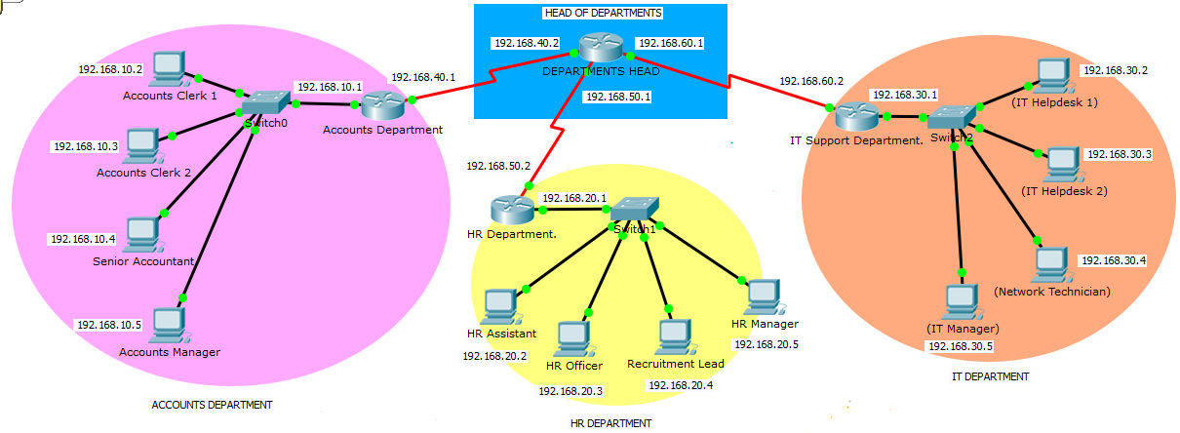
- Router0 is Head
- Router1 is assigned to the Accounts Department.
- Router2 is assigned to the HR Department.
- Router3 is assigned to the IT Support Department.

- DELIVERABLES:
- CLI OF ROUTER0 (HEAD):
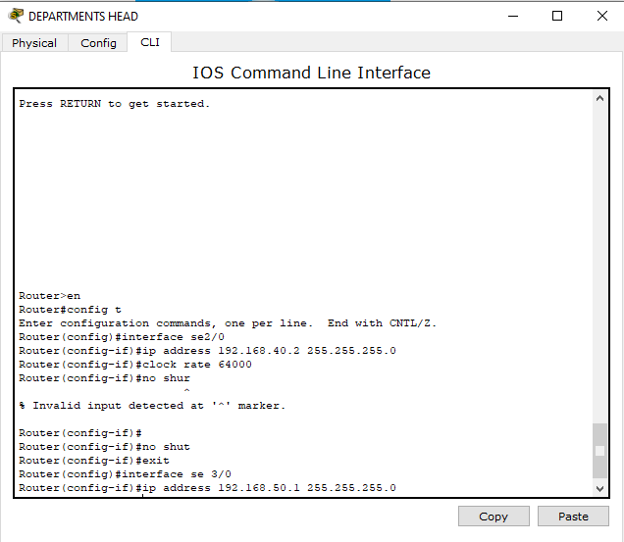
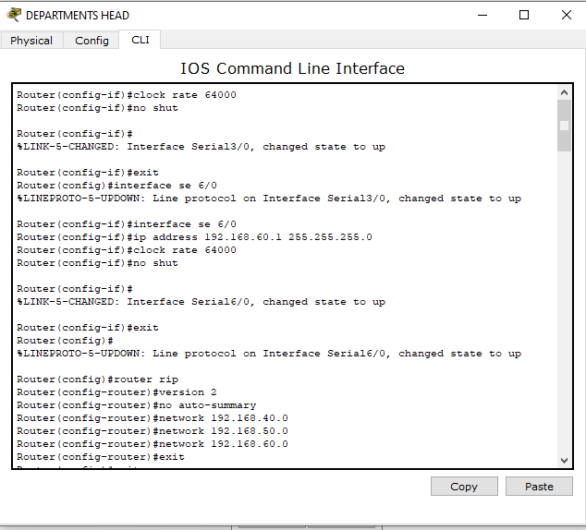
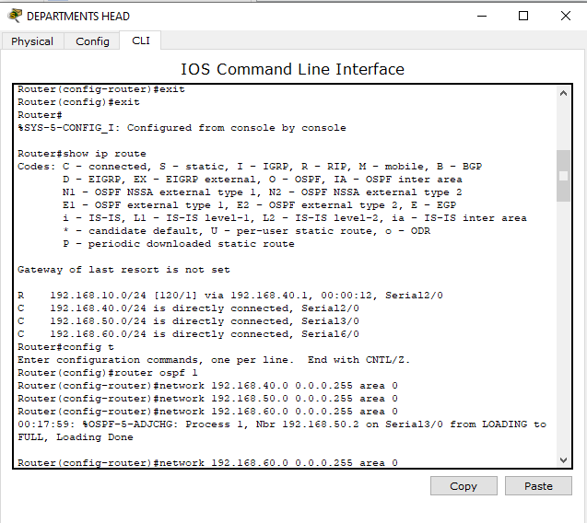
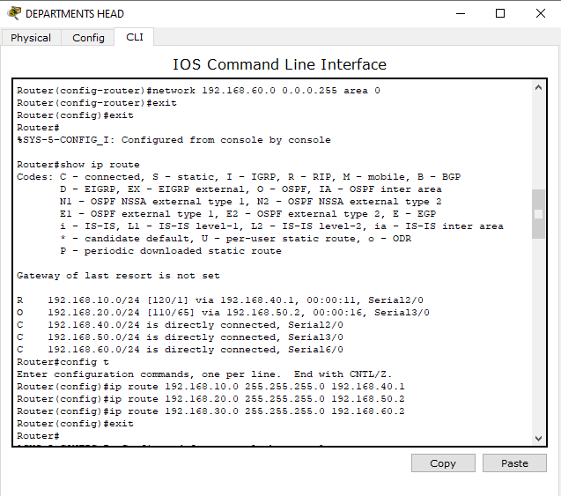
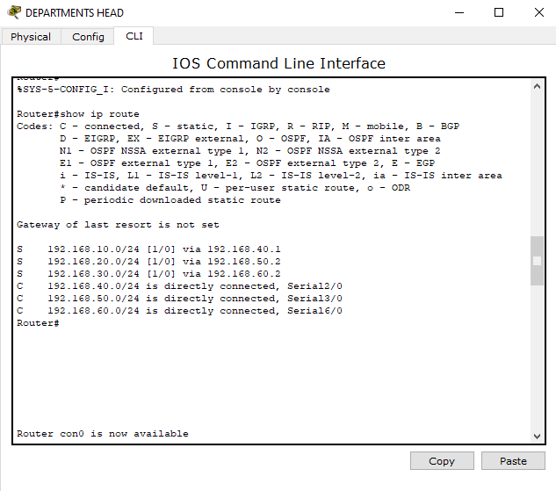

- CLI OF ROUTER1 (ACCOUNTS):
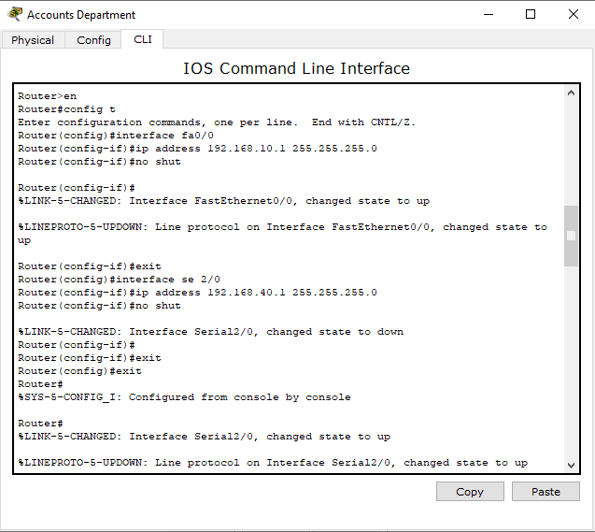
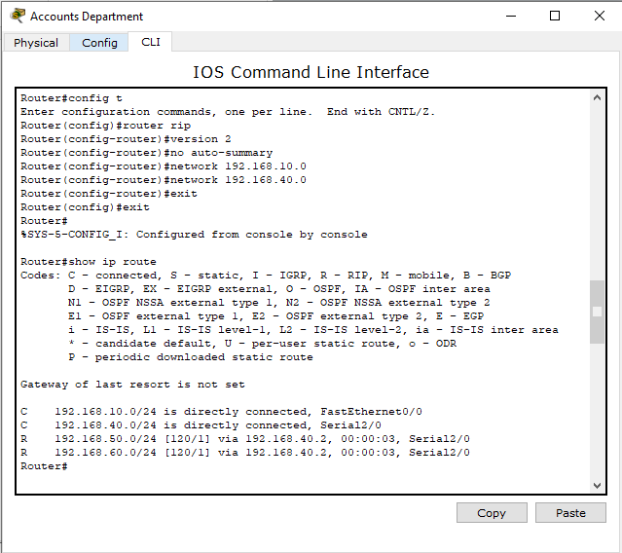
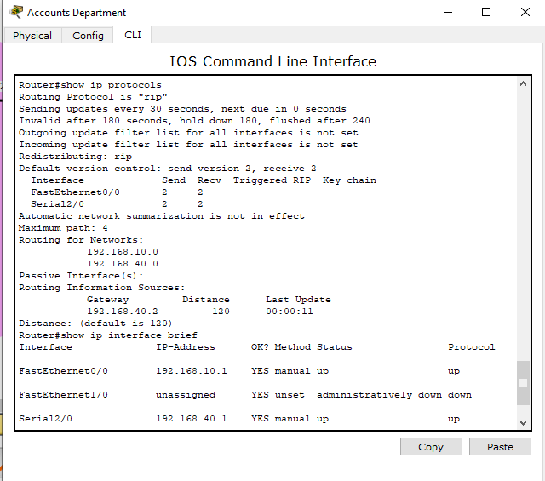
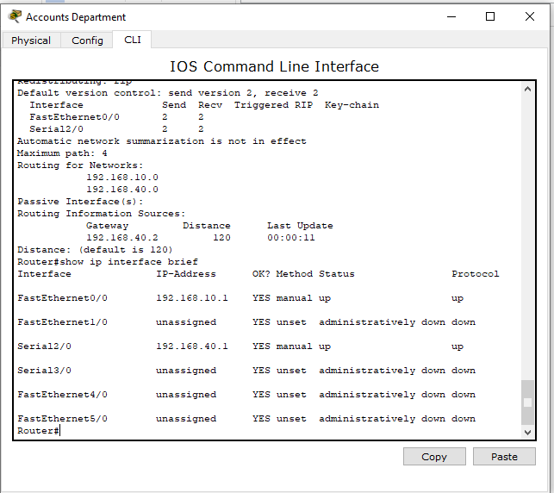

- CLI OF ROUTER2 (HR):
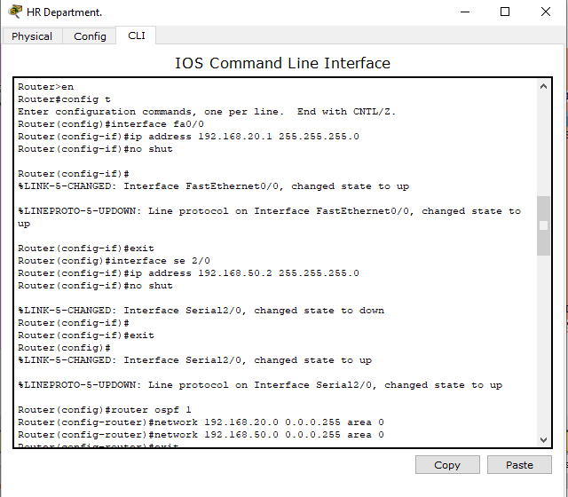
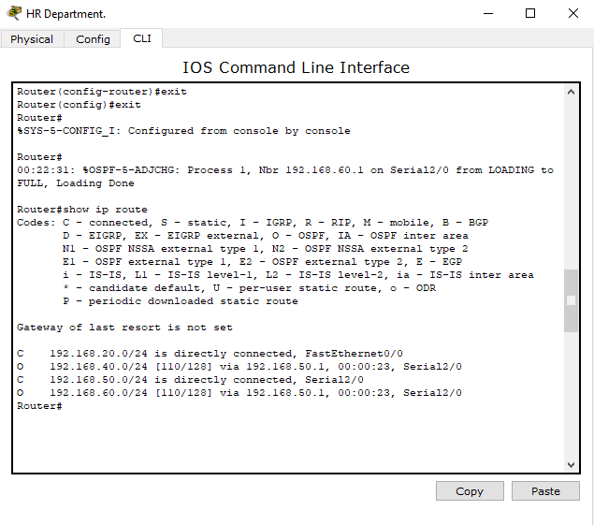
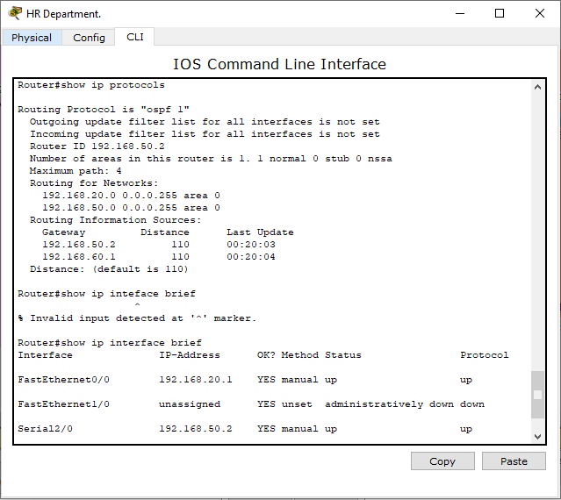
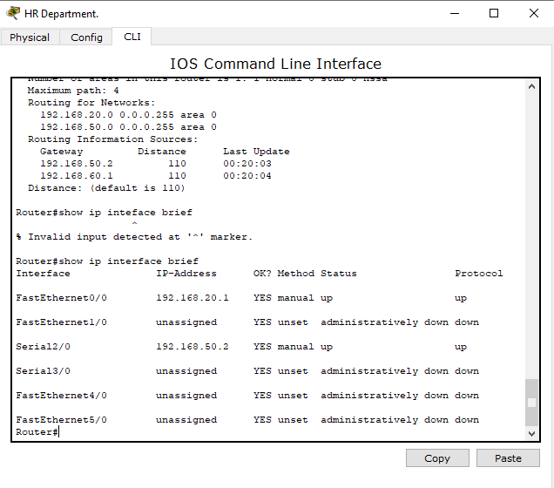

- CLI OF ROUTER3 (IT):
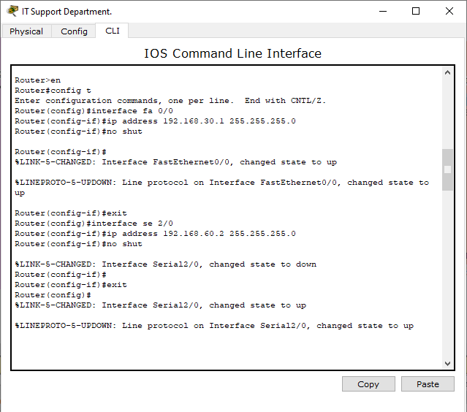
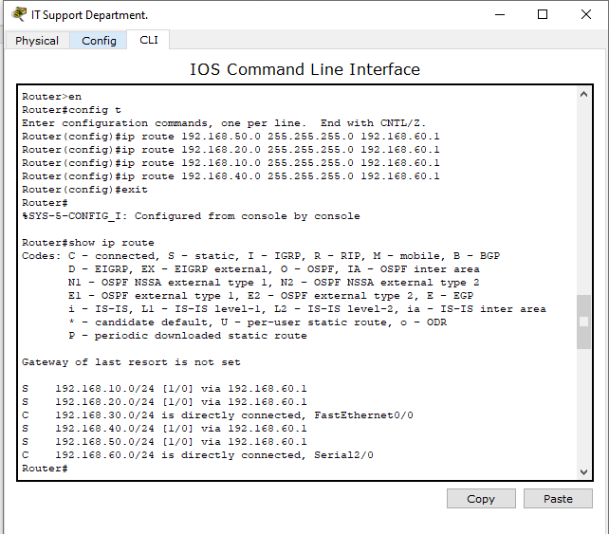
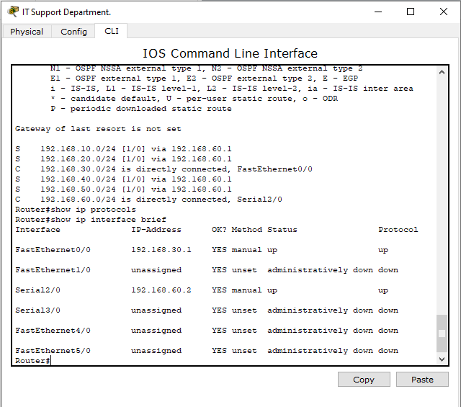

- PING FROM PC0 TO ROUTER0 (ACCOUNT CLERK 1 TO HEAD):
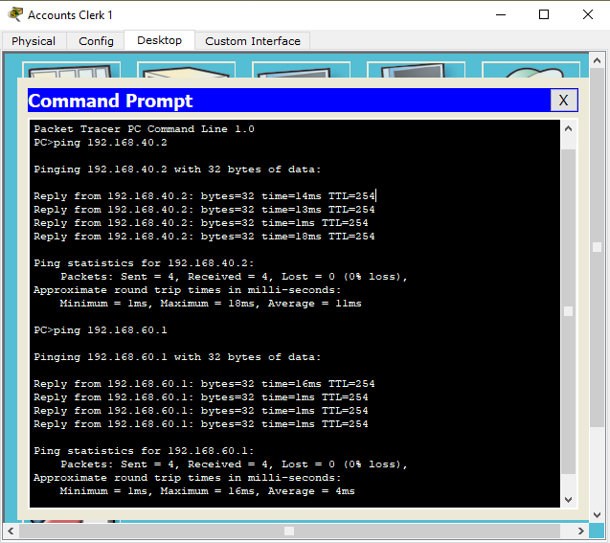
- PING FROM PC5 TO ROUTER0 (HR OFFICER TO HEAD):
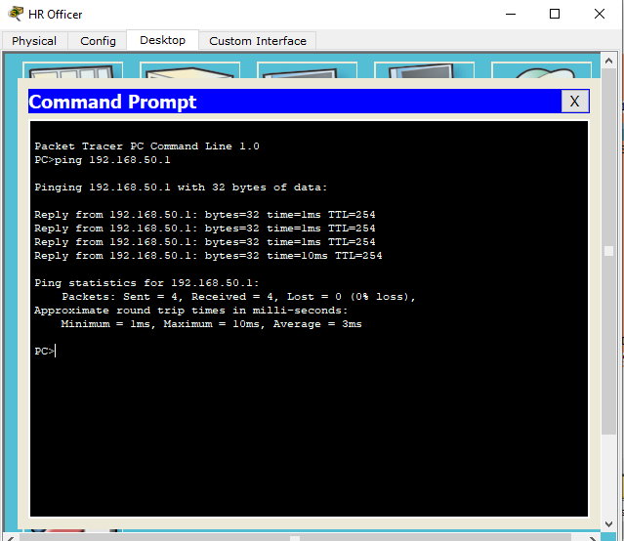
- PING FROM PC11 TO ROUTER0 (IT MANAGER TO HEAD):
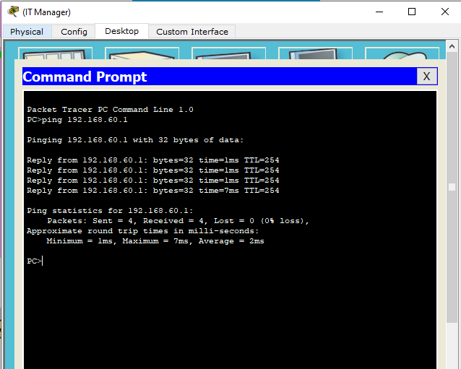

- CONCLUSION:
This project demonstrates how a hybrid routing environment simulates a real-world office or institutional network. The use of RIP, OSPF, and Static routing allows network segmentation, controlled communication, and centralized monitoring through the Head Office. Students gain hands-on experience with routing protocols, inter-network communication, and scalable network design. Such projects prepare students for modern network administration and design in enterprise-level infrastructures.

